A Peek at Our Week Ladybugs with Rosanne & Marianne Date: March 5-9
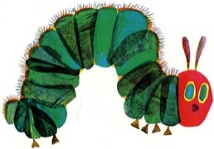
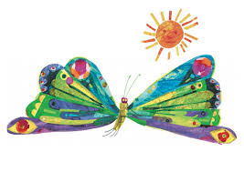
Theme: Eric Carle Week
Books:  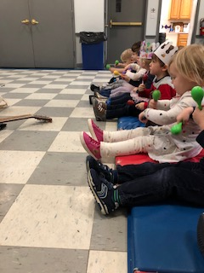  -The Very Hungry Caterpillar  -Brown Bear, Brown Bear  -Polar Bear, Polar Bear  -The Very Busy Spider  -Little Cloud  -From Head to Toe  -10 Little Rubber Ducks | Circle Activities:  -Hello Song  -Introducing Eric Carle and some of his books  -Taking turns to act like/sing about our favorite animal  -Taking turns to share something we see in the classroom like in the brown bear book  -Brown Bear, Brown Bear Flannel Board  -The Very Hungry Caterpillar Flannel Board  -Doing the movements together as we read the From Head to Toe book
Table Activities:  -Pom-pom fine motor game  -Magnetic shapes  -Geometric shape boards  -Alphabet snap blocks  -Mini rubber ducks with blocks  -Paper, scissor, crayons  -Model Magic | Gym:  -Riding tricycles and cozy coup cars  -Tool Bench  -Wood Blocks  -Kicking balls into soccer goals  -Hockey goals  -Crawl through tunnels
Art Activities:  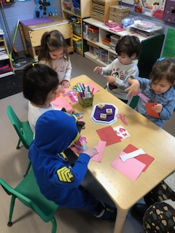  -Tissue Paper Collage Art  -Coffee Filter Butterflies  -Painting with all the colors of the rainbow, experimenting with color | Math & Science:  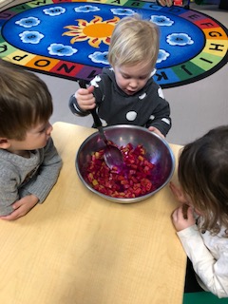  -Color mixing during painting  -Moon Sand in the sensory bin  -Color bug counters, patterning  -Experiment: Microwave a bar of ivory soap to make our own cloud
Skills We Are Working On:  Social/Emotional:  -Building self-confidence  -Sharing at circle  -Verbalizing frustrations & needs  -Taking turns, sharing  -Learning classroom routines  -Helping at clean up time  Self-help:  -Putting on jackets, mittens, hats  Cognitive:  -Sitting at circle  -Following 2-3 step directions  -Learning about the author and illustrator Eric Carle  -Recognizing animals/insects in the stories, sharing our favorite animals, describing what we see  -Observing what happens when we microwave the soap, predicting what will happen, exploring the soap with our senses  -Recognizing our names without pictures  -Sharing ideas at circle  -Shape and color recognition  -Counting 1-5  Fine Motor:  Strengthening hand muscles (pincer grasp)  Working on proper hand placement while cutting with scissors/using a crayon/brush  Gross Motor:  Different body action movements during movement songs  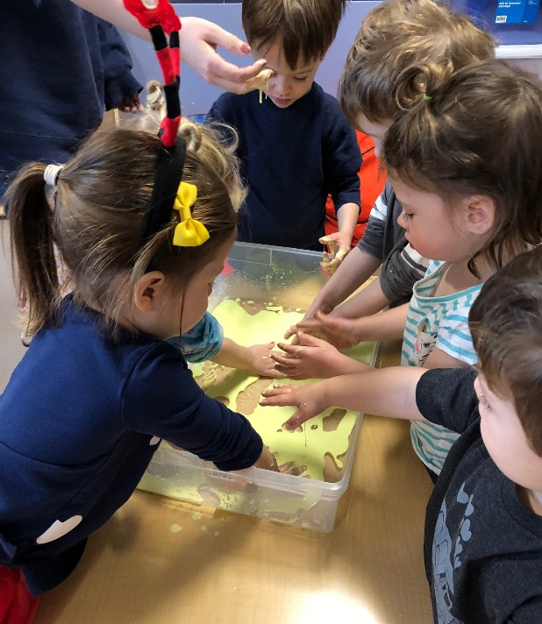  UsingW big body movements during gym activities  Wacky Wednesday with OObleck & | Notes for Parents:  March is our Read Aloud month, when we invite the parents to come in to share and read a book to our class. The best times to come are at drop off and before pick up (11:05.) Please check with us to schedule a time and we will pencil you into our calendar.  We will be sending home paper leaves for you to write your book title and author, and we will hang them on the school reading tree that will be displayed in the hallway.  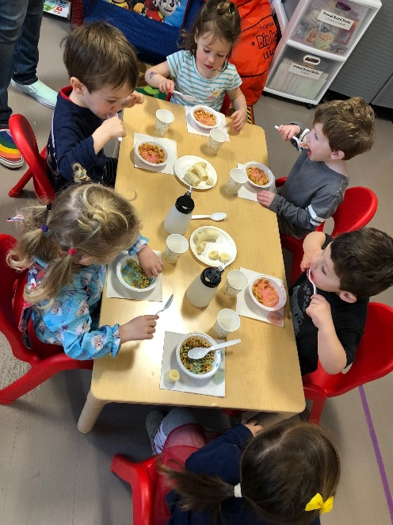  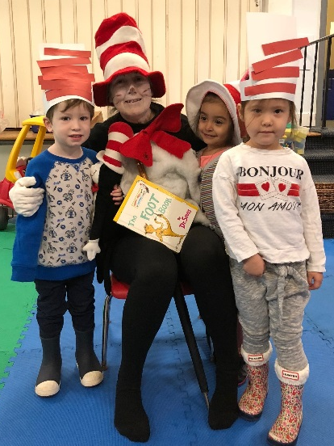  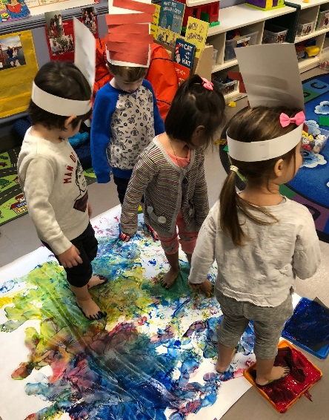  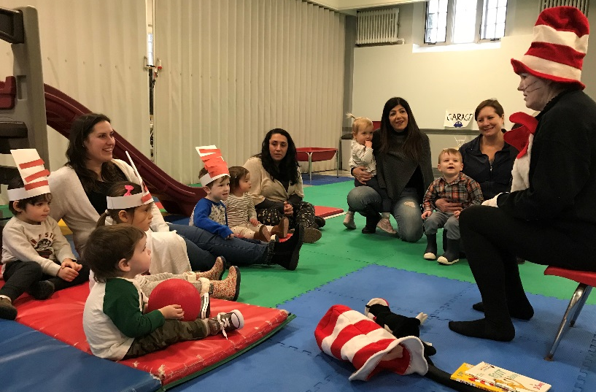  Cat in the Hat visit!  Painting with our feet???  Pink milk??

